__________________________________________________________
EMORY UNIVERSITY SCHOOL OF MEDICINE

DEPARTMENT OF CELL BIOLOGY

__________________________________________________________

“BLOC-1 and the Homeostatic Control of
Synaptic Strength”

Presented by

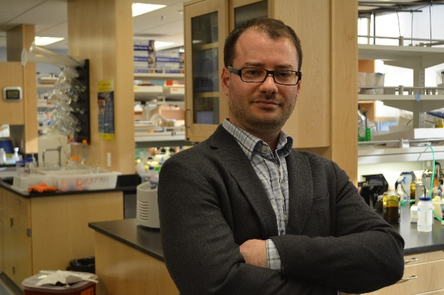

Dion Dickman, Ph.D.

Assistant Professor
Department of Biology, Neurobiology Section
University of Southern California

Wednesday, March 16, 2016
4:00PM

Whitehead Biomedical Research Building, Room 400

Light Refreshments served at 3:30PM

